TOC LAB MANUAL

Experiment 1: DFA Simulation for Strings that Start with a and End with a
Aim
To write a C program to simulate a Deterministic Finite Automata (DFA) that accepts strings starting with a and ending with a.
Procedure
- Start the program.
- Read the input string.
- Check whether the first character is a.
- Check whether the last character is a.
- If both conditions are true, display String Accepted.
- Otherwise, display String Rejected.
- Stop the program.
Algorithm
- Start.
- Read the input string.
- Find the length of the string.
- If the first character is 'a' and the last character is 'a', print Accepted.
- Otherwise, print Rejected.
- Stop.
C Program
#include <stdio.h>
#include <string.h>

int main()
{
char str[100];
int len;

printf("Enter the string: ");
scanf("%s", str);

len = strlen(str);

if(str[0] == 'a' && str[len - 1] == 'a')
printf("String Accepted");
else
printf("String Rejected");

return 0;
}
Input
abba
Output
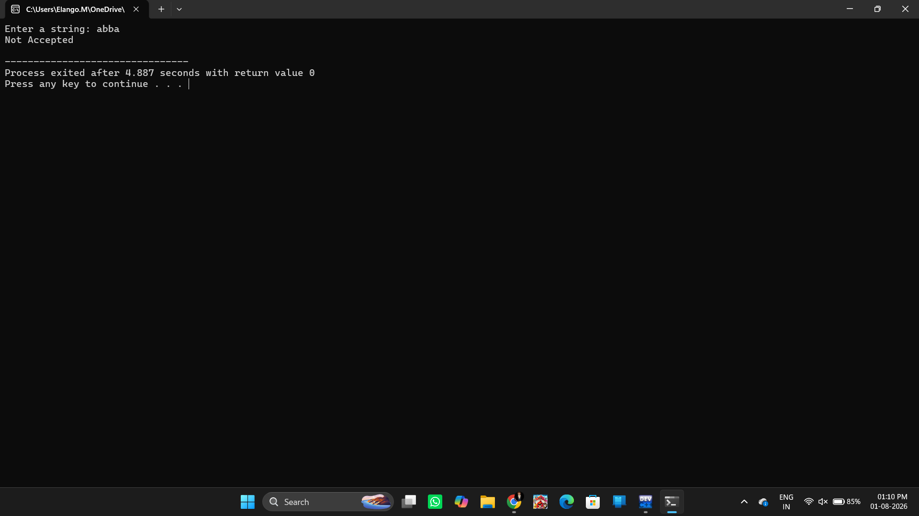
String Accepted
Result
Thus, the C program to simulate a Deterministic Finite Automata (DFA) for strings that start with 'a' and end with 'a' was successfully implemented and verified with sample inputs.

Experiment 2: NFA Simulation for Strings that Start with 0 and End with 1
Aim
To write a C program to simulate a Non-Deterministic Finite Automata (NFA) that accepts strings starting with 0 and ending with 1.
Procedure
- Start the program.
- Read the input string.
- Check whether the first character is 0.
- Check whether the last character is 1.
- If both conditions are true, display String Accepted.
- Otherwise, display String Rejected.
- Stop the program.
Algorithm
- Start.
- Read the input string.
- Find the length of the string.
- If the first character is '0' and the last character is '1', print Accepted.
- Otherwise, print Rejected.
- Stop.
C Program
#include <stdio.h>
#include <string.h>
int main()
{
char str[100];
int len;
printf("Enter the binary string: ");
scanf("%s", str);
len = strlen(str);
if(str[0] == '0' && str[len - 1] == '1')
printf("String Accepted");
else
printf("String Rejected");
return 0;
}
Input
01101
Output
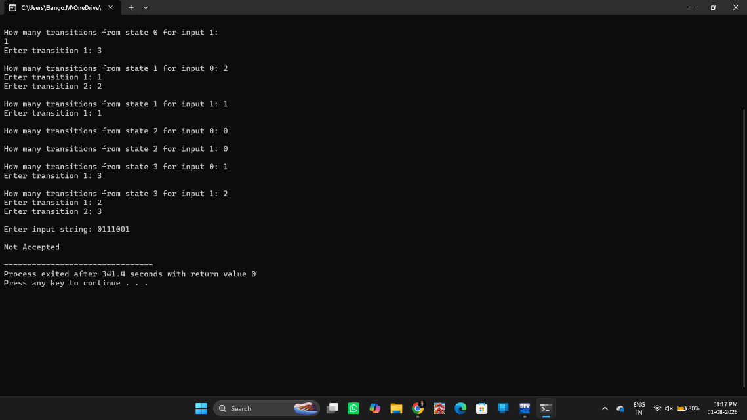
String Accepted

Result
Thus, the C program to simulate a Non-Deterministic Finite Automata (NFA) for binary strings that start with 0 and end with 1 was successfully implemented and tested with sample inputs.

Experiment 3: ε-Closure for All States in an NFA with ε-Moves
Aim
To write a C program to find the ε-closure for all the states in a Non-Deterministic Finite Automata (NFA) with ε-moves.
Procedure
- Start the program.
- Define the ε-transitions for each state.
- Find the ε-closure of every state by including the state itself and all states reachable through ε-transitions.
- Display the ε-closure of each state.
- Stop the program.
Algorithm
- Start.
- Define the ε-transition table.
- For each state:
  - Include the state in its ε-closure.
  - Recursively visit all states reachable through ε-transitions.
- Print the ε-closure for every state.
- Stop.
C Program
#include <stdio.h>

int e[10][10], visited[10], n;

void eclosure(int state)
{
int i;

if(visited[state])
return;

visited[state] = 1;
printf("q%d ", state);

for(i = 0; i < n; i++)
{
if(e[state][i] == 1)
eclosure(i);
}
}

int main()
{
int i, j;

printf("Enter the number of states: ");
scanf("%d", &n);

printf("Enter the epsilon transition matrix:\n");

for(i = 0; i < n; i++)
{
for(j = 0; j < n; j++)
{
scanf("%d", &e[i][j]);
}
}

for(i = 0; i < n; i++)
{
for(j = 0; j < n; j++)
visited[j] = 0;

printf("\nE-Closure(q%d) = { ", i);
eclosure(i);
printf("}");
}

return 0;
}
Input
Enter the number of states: 3
Enter the epsilon transition matrix:
0 1 0
0 0 1
0 0 0
Output
E-Closure(q0) = { q0 q1 q2 }
E-Closure(q1) = { q1 q2 }
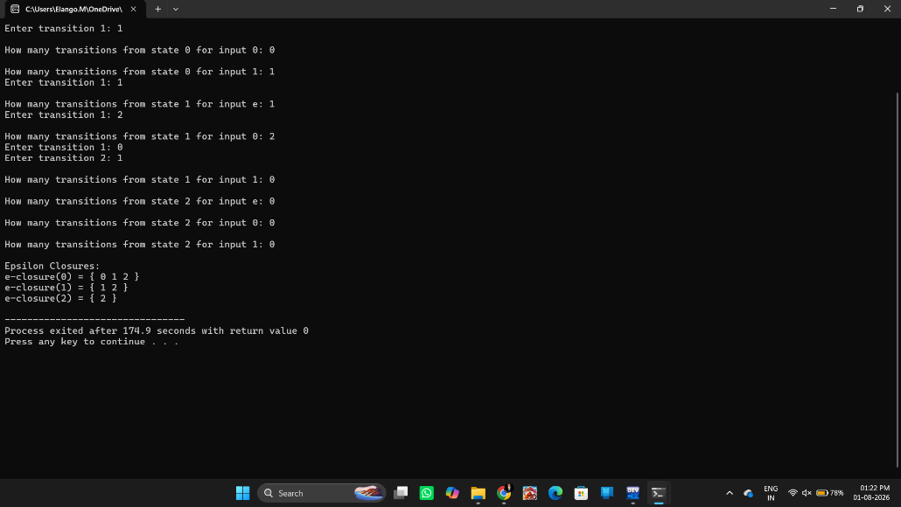
E-Closure(q2) = { q2 }

Result
Thus, the C program to find the ε-closure for all the states in an NFA with ε-moves was successfully implemented and executed.

Experiment 4: Check Whether a String Belongs to the Grammar
Aim
To write a C program to check whether a given string belongs to the grammar:
S → 0 A 1
A → 0 A | 1 A | ε
Procedure
- Start the program.
- Read the input string.
- Check whether the string starts with 0 and ends with 1.
- Ensure the string length is at least 2.
- If the conditions are satisfied, display String Accepted.
- Otherwise, display String Rejected.
- Stop the program.
Algorithm
- Start.
- Read the input string.
- Find the length of the string.
- If the first character is '0', the last character is '1', and the length is at least 2, print Accepted.
- Otherwise, print Rejected.
- Stop.

C Program
#include <stdio.h>
#include <string.h>

int main()
{
char str[100];
int len;
printf("Enter the string: ");
scanf("%s", str);
len = strlen(str)
if(len >= 2 && str[0] == '0' && str[len - 1] == '1')
printf("String Accepted");
else
printf("String Rejected");
return 0;
}
Input
0011
Output
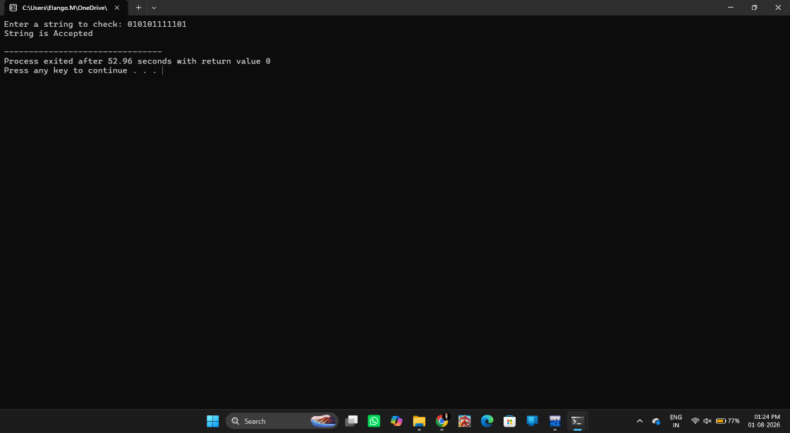
String Accepted
Result
Thus, the C program to check whether a given string belongs to the grammar
S → 0 A 1
A → 0 A | 1 A | ε
was successfully implemented and tested with sample inputs.

Experiment 5: Check Whether a String Belongs to the Grammar
Aim
To write a C program to check whether a given string belongs to the grammar:
S → 0 S 0 | 1 S 1 | 0 | 1 | ε
Procedure
- Start the program.
- Read the input string.
- Compare the characters from the beginning and the end of the string.
- If all corresponding characters are equal, the string belongs to the grammar.
- Otherwise, reject the string.
- Display the result.
- Stop the program.
Algorithm
- Start.
- Read the input string.
- Set two pointers: one at the beginning and one at the end.
- Compare both characters.
- If they are equal, move the pointers inward.
- Repeat until the pointers meet.
- If all characters match, print String Accepted; otherwise, print String Rejected.
- Stop.
C Program
#include <stdio.h>
#include <string.h>

int main()
{
char str[100];
int i, len, flag = 1;

printf("Enter the string: ");
scanf("%s", str);

len = strlen(str);

for(i = 0; i < len / 2; i++)
{
if(str[i] != str[len - i - 1])
{
flag = 0;
break;
}
}

if(flag)
printf("String Accepted");
else
printf("String Rejected");

return 0;
}
Input
0110
Output
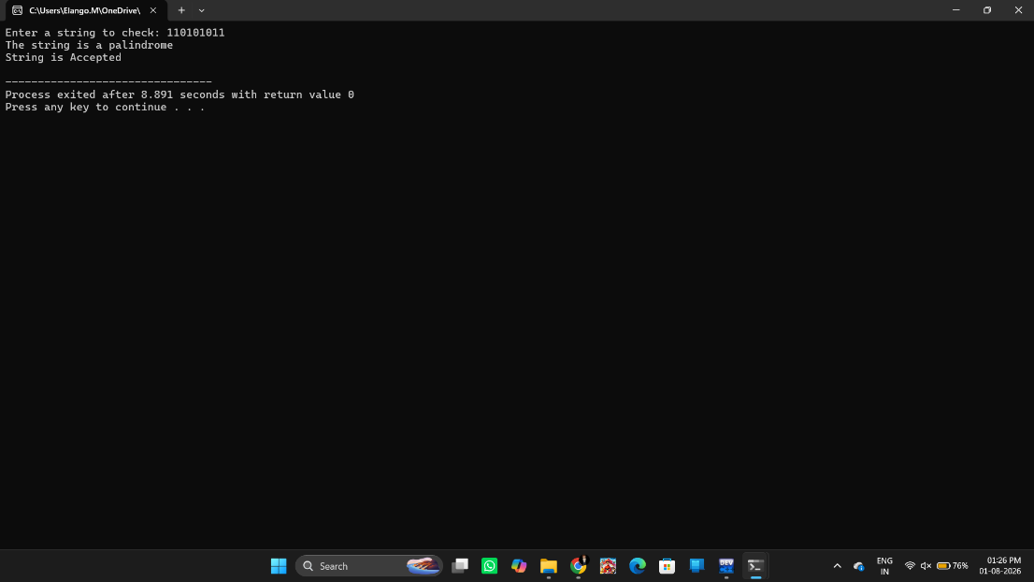
String Accepted

Result
Thus, the C program to check whether a string belongs to the grammar
S → 0 S 0 | 1 S 1 | 0 | 1 | ε
was successfully implemented and tested with sample inputs.

Experiment 6: Check Whether a String Belongs to the Grammar
Aim
To write a C program to check whether a given string belongs to the grammar:
S → 0 S 0 | A
A → 1 A | ε
Procedure
- Start the program.
- Read the input string.
- Count the number of leading 0s and trailing 0s.
- Check whether the number of leading and trailing 0s is equal.
- Verify that the remaining middle characters (if any) are all 1s.
- If all conditions are satisfied, display String Accepted.
- Otherwise, display String Rejected.
- Stop the program.
Algorithm
- Start.
- Read the input string.
- Count leading 0s.
- Count trailing 0s.
- If both counts are not equal, reject the string.
- Check that the remaining characters are only 1s.
- If true, print String Accepted; otherwise, print String Rejected.
- Stop.
C Program
#include <stdio.h>
#include <string.h>

int main()
{
char str[100];
int len, left = 0, right = 0, i;

printf("Enter the string: ");
scanf("%s", str);

len = strlen(str);

while(left < len && str[left] == '0')
left++;

while(right < len && str[len - 1 - right] == '0')
right++;

if(left != right)
{
printf("String Rejected");
return 0;
}

for(i = left; i < len - right; i++)
{
if(str[i] != '1')
{
printf("String Rejected");
return 0;
}
}

printf("String Accepted");

return 0;
}
Input
001100

Output
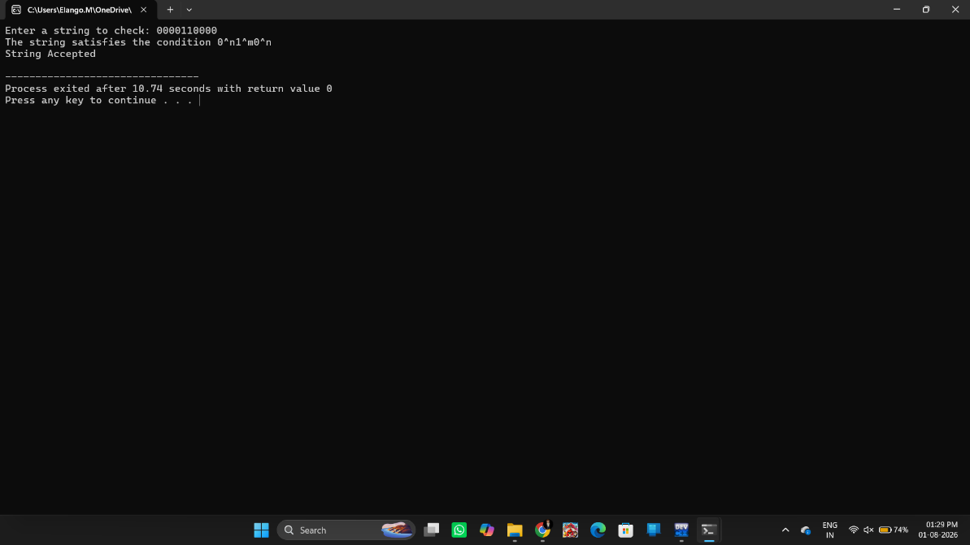
String Accepted

Result
Thus, the C program to check whether a given string belongs to the grammar
S → 0 S 0 | A
A → 1 A | ε
was successfully implemented and tested with sample inputs.

Experiment 7: Check Whether a String Belongs to the CFG
Aim
To write a C program to check whether a given string belongs to the language defined by the Context Free Grammar (CFG):
S → 0S1 | ε
Procedure
- Start the program.
- Read the input string.
- Count the number of leading 0s.
- Count the number of trailing 1s.
- Check whether both counts are equal.
- Verify that all leading characters are 0 and all trailing characters are 1.
- If all conditions are satisfied, display String Accepted.
- Otherwise, display String Rejected.
- Stop the program
Algorithm
- Start.
- Read the input string.
- Count the leading 0s.
- Count the trailing 1s.
- If both counts are equal and together cover the entire string, print String Accepted.
- Otherwise, print String Rejected.
- Stop.
C Program
#include <stdio.h>
#include <string.h>

int main()
{
char str[100];
int len, zero = 0, one = 0;

printf("Enter the string: ");
scanf("%s", str);

len = strlen(str);

while(zero < len && str[zero] == '0')
zero++;

while(one < len && str[len - 1 - one] == '1')
one++;

if(zero == one && zero + one == len)
printf("String Accepted");
else
printf("String Rejected");

return 0;
}
Input
0011
Output
String Accepted

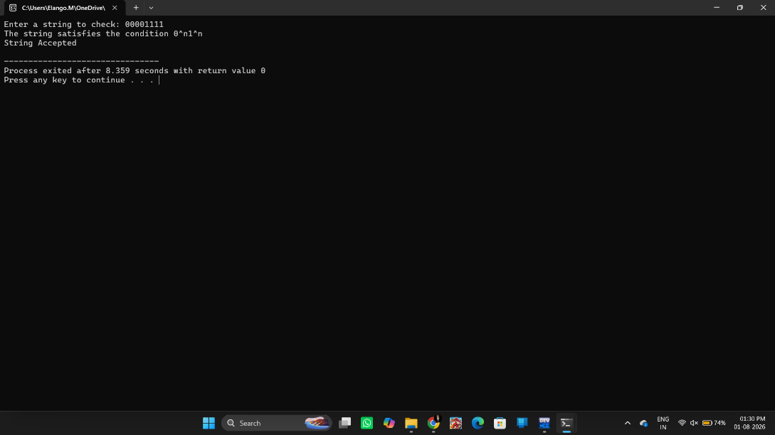
Result
Thus, the C program to check whether a given string belongs to the Context Free Grammar (CFG)
S → 0S1 | ε
was successfully implemented and verified with sample inputs.

Experiment 8: Check Whether a String Belongs to the CFG
Aim
To write a C program to check whether a given string belongs to the language defined by the Context Free Grammar (CFG):
S → A101A
A → 0A | 1A | ε
Procedure
- Start the program.
- Read the input string.
- Check whether the substring "101" is present in the string.
- If "101" is found, display String Accepted.
- Otherwise, display String Rejected.
- Stop the program.
Algorithm
- Start.
- Read the input string.
- Search for the substring "101".
- If "101" is present, print String Accepted.
- Otherwise, print String Rejected.
- Stop.

C Program
#include <stdio.h>
#include <string.h>

int main()
{
char str[100];

printf("Enter the string: ");
scanf("%s", str);

if(strstr(str, "101") != NULL)
printf("String Accepted");
else
printf("String Rejected");

return 0;
}
Input
101
Output
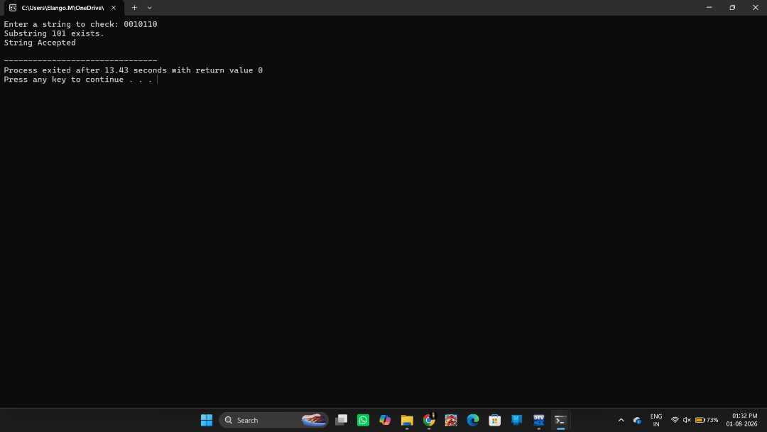
String Accepted

Result
Thus, the C program to check whether a given string belongs to the language defined by the Context Free Grammar (CFG)
S → A101A
A → 0A | 1A | ε
was successfully implemented and tested successfully.

